Leader Training

Become a Class Coach – A Matter of Balance

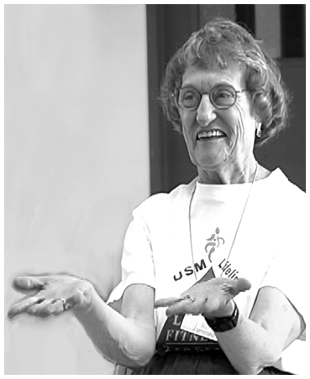  A Matter of Balance is an award-winning program designed for older adults to manage falls and increase activity levels.  Two trained coaches guide participants through learning and  activities that emphasize strategies to reduce fear of falling and increase activity levels among older adults.  Participants show improved balance, flexibility and strength while viewing falls as controllable. | WHAT’S REQUIRED TO BE A COACH?  - Willingness to lead small groups  - Good communication and interpersonal skills  - Enthusiastic and motivating – able to guide discussions  - Manage class logistics including attendance, evaluations and fees  - Willingness to coach classes at least twice per year  - Ability to perform range of motion and low-level endurance exercises – ability to carry 20 lb.  TOPICS INCLUDE:  - Promote a view of falls and fear of falling as controllable  - Setting realistic goals for increasing activity  - Changes to the environment to reduce fall risk factors  - Promote exercise and activities to increase strength and balance.  CLASS SCHEDULE  8 weeks, 1x per week, 2 hr. per session – 16 hours total  OR twice a week for 4 weeks, 2 hrs. each.  Learn more, visit:  http://www.mainehealth.org/mob

A MATTER OF BALANCE LEADER TRAINING SCHEDULE
Days/Dates: 8 hrs coach training;
Time:
Place:
Training is offered free of charge and includes mileage reimbursement and lunch.

To register or learn more: Contact Katey Fornear, 218-529-7531 or kfornear@ardc.org

Sponsored by the Arrowhead Agency on Aging, Duluth, MN | arrowheadaging.org

